For Part 1 of the project you will download and analyze some data from WRDS

Go to wrds.wharton.upenn.edu

Login using provided credentials

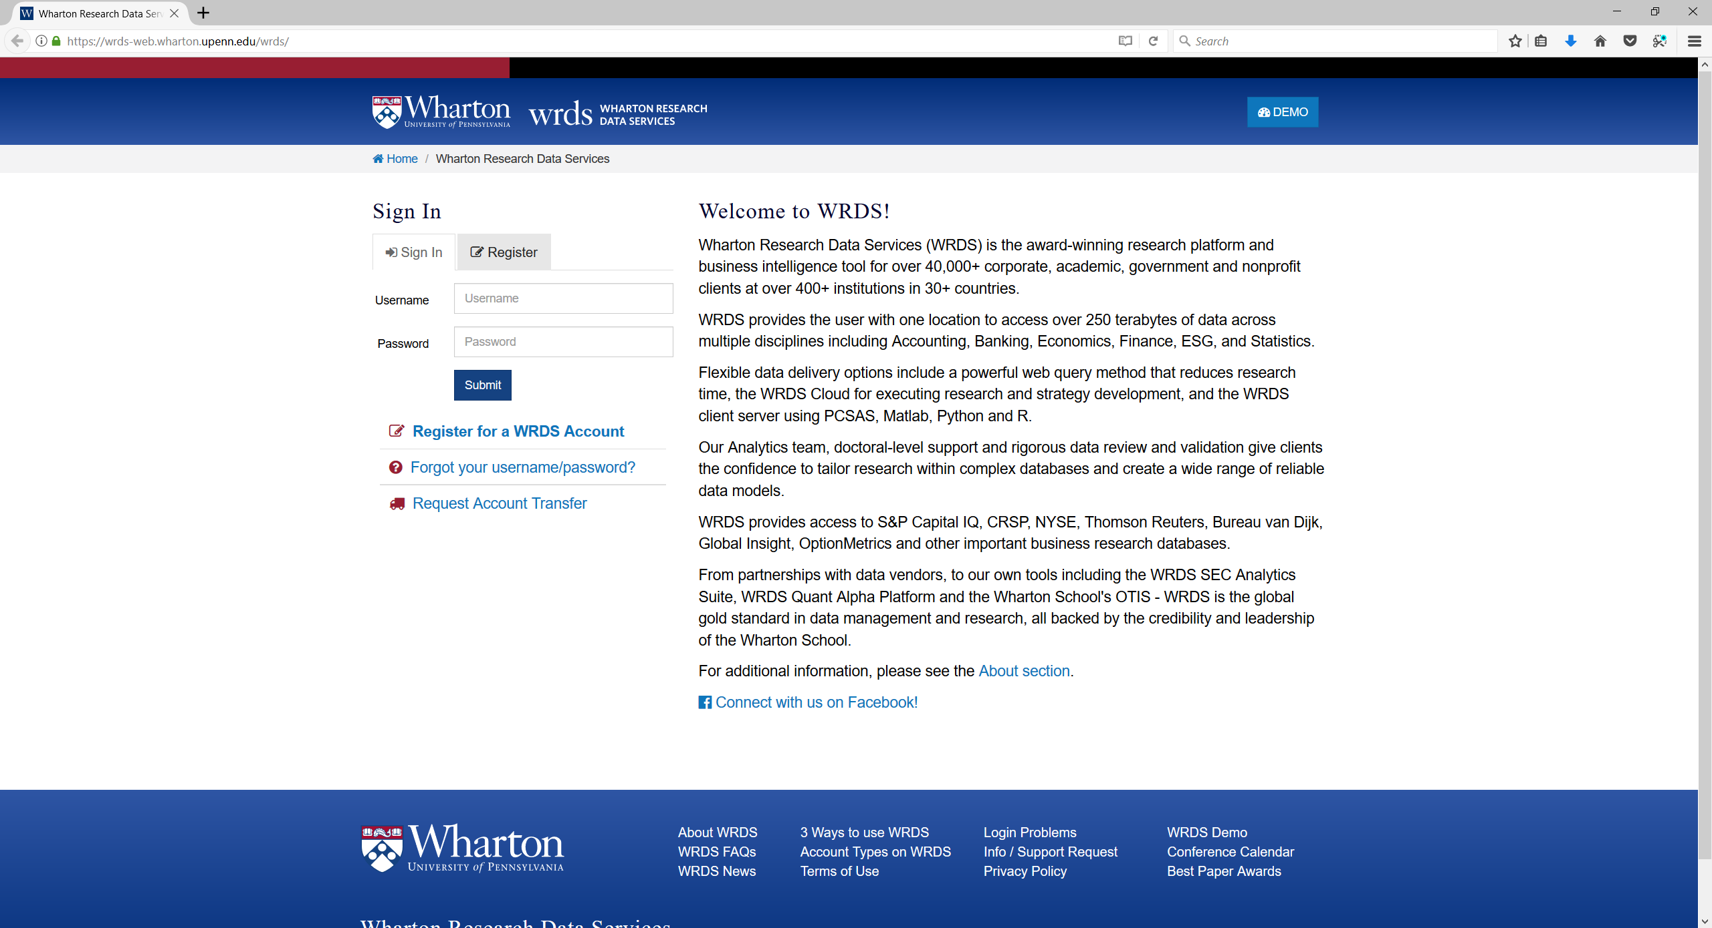

Accept terms, choose home, and select Compustat – Capital IQ

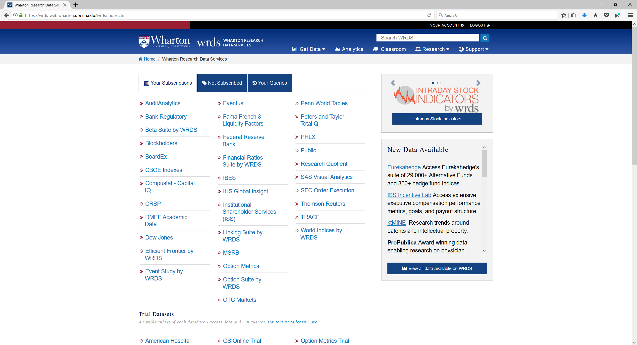

Click on North America - Daily

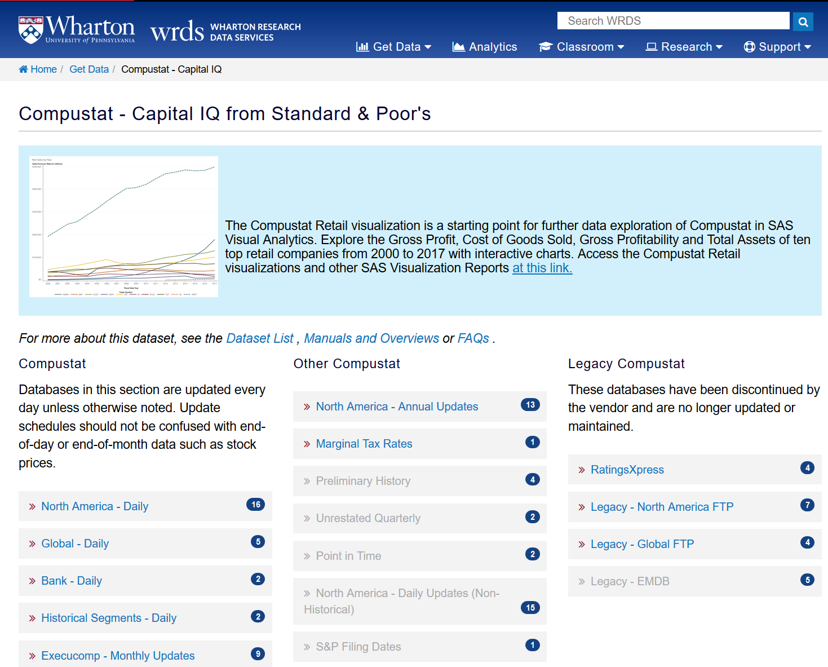

Choose Fundamentals Annual

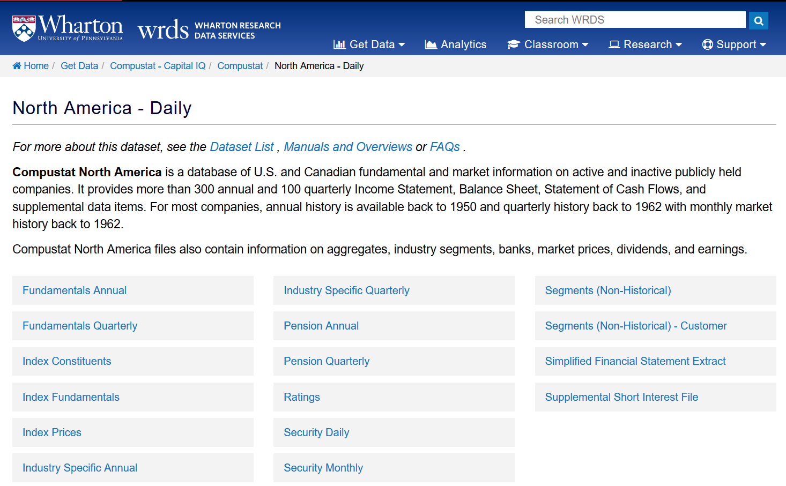

Choose **Fiscal Year** for date variable in step 1, and set date range to 2015-01 to 2015-12, – **you WILL get wrong answers if you skip this step.. you will lose points ,** under step 2 put search entire database

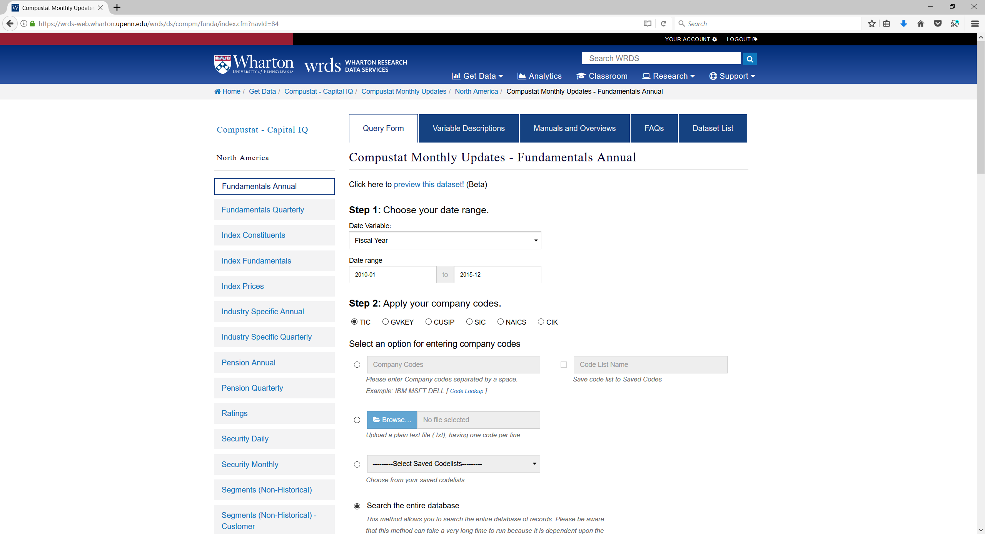

You will need to scroll down to step 3 and select variables

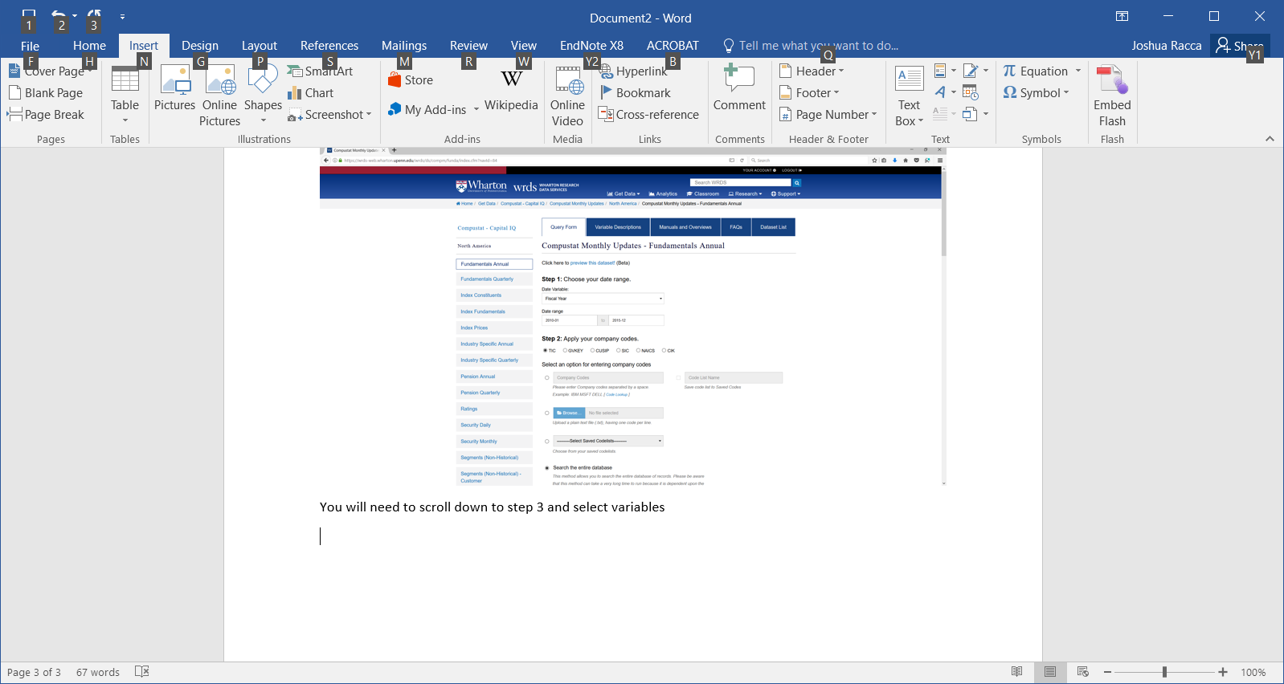

You will need the following variables (can be found under search all tab)

Company name, SIC, AT, IB, SALE (GVKEY will be included, you cannot get rid of it, and you will need it anyway)

These are present, but you may have to scroll down quite a way, the variables are in order for each financial statement, so AT is in the balance sheet, while IB and SALE are further down in the income statement grouping

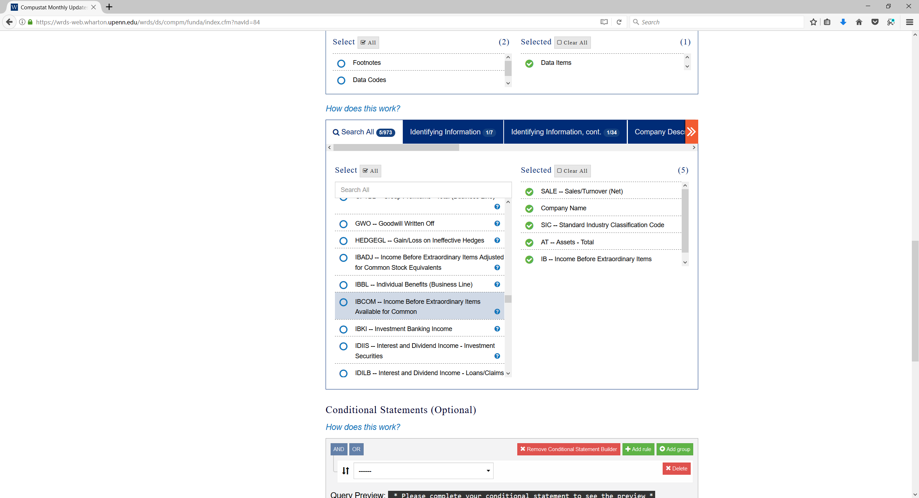

Next use conditional statements to limit download to your industry, if your industry was 2311 you would use the following (2311 is not for anyone in this class, feel free to try it if you like)

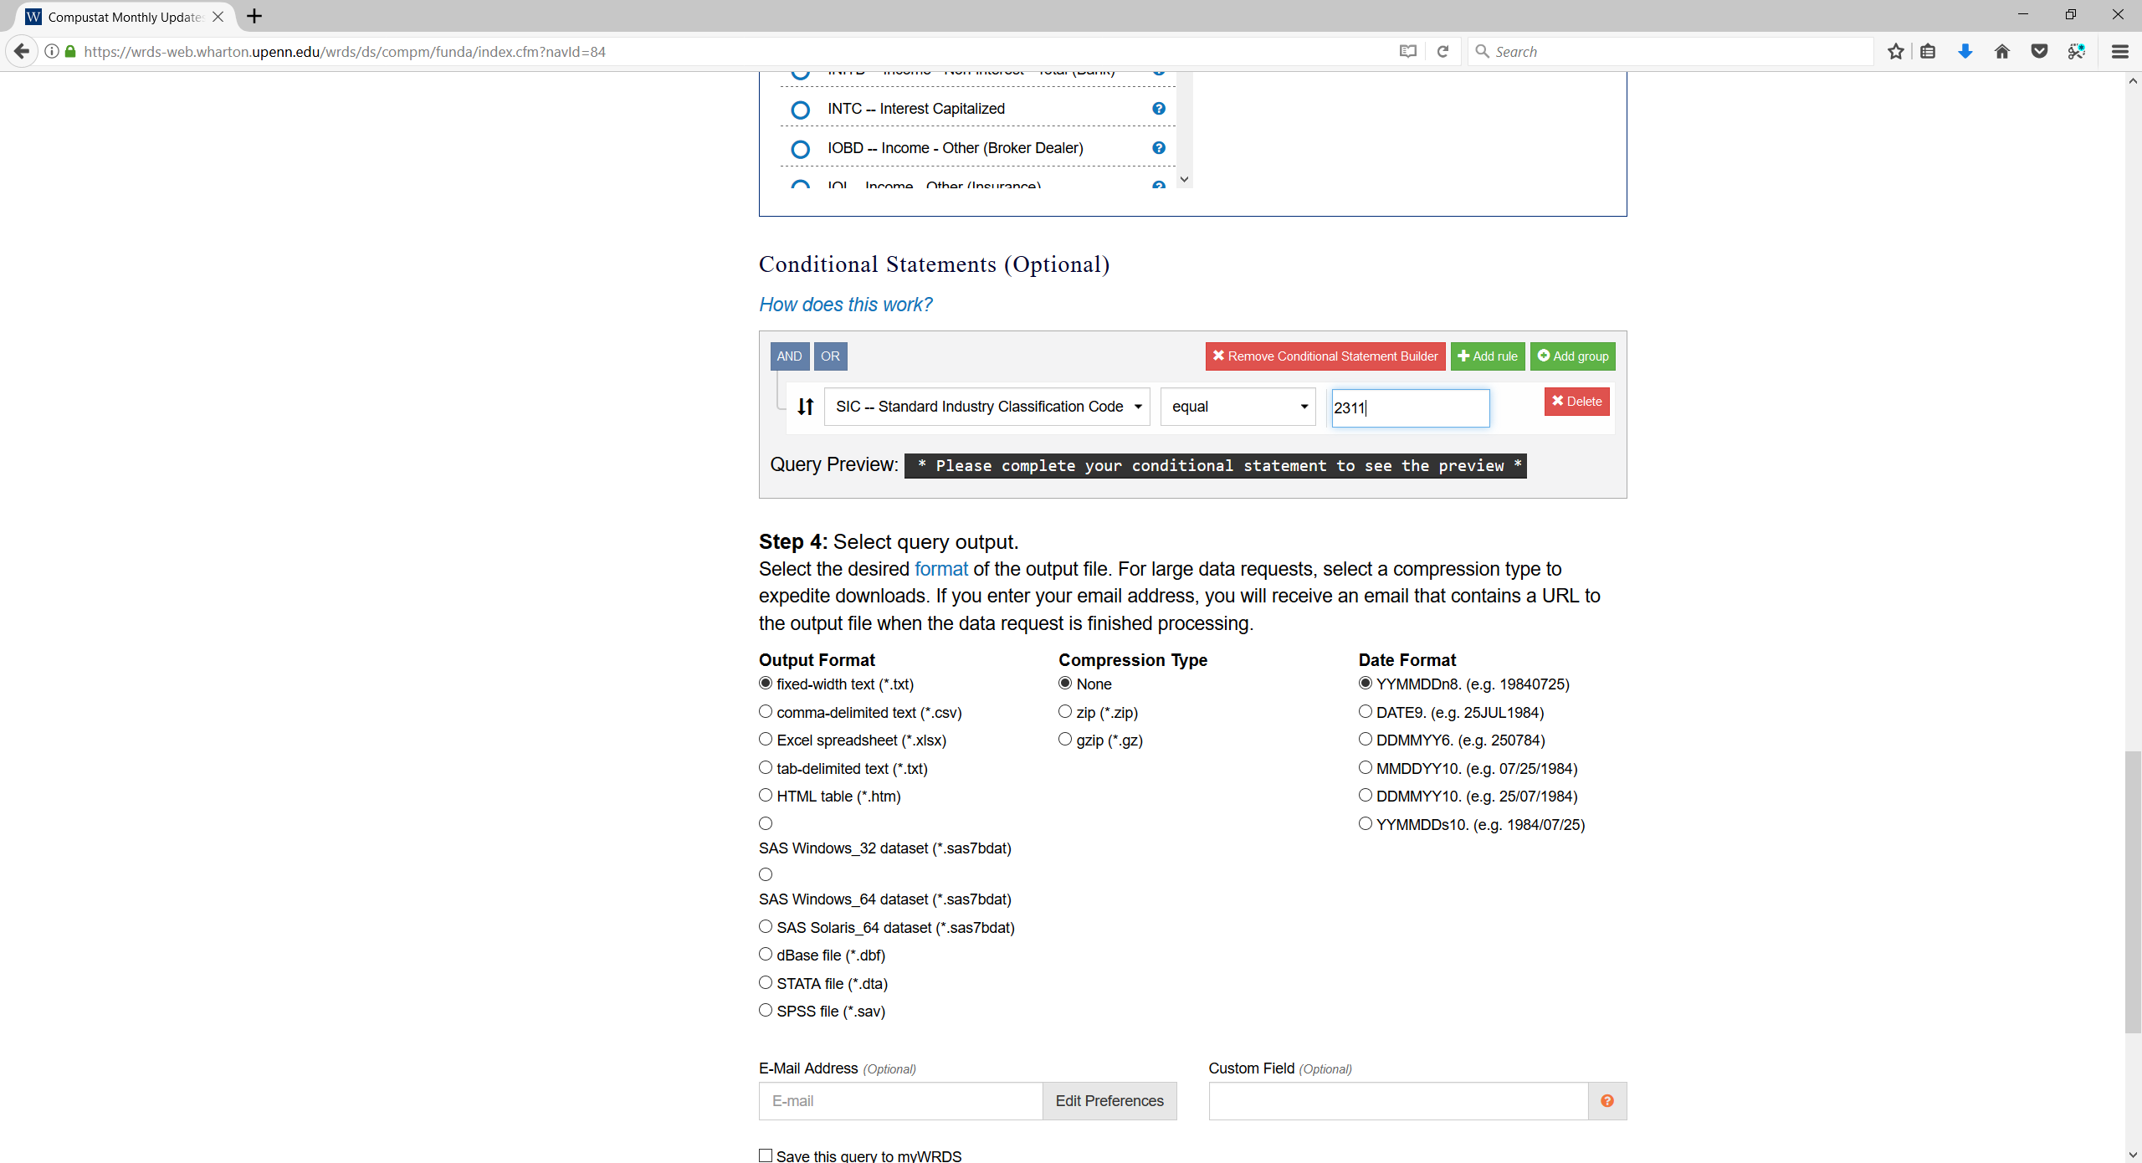

Next choose your format, Choose Excel. No compression is necessary and date format is not important, you can enter your email if you like (suggested) If you choose to use the save query then make sure your name is part of the query name

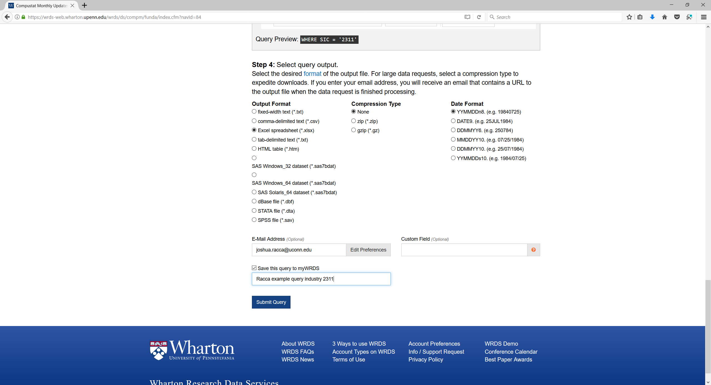

You will see this screen while the query runs

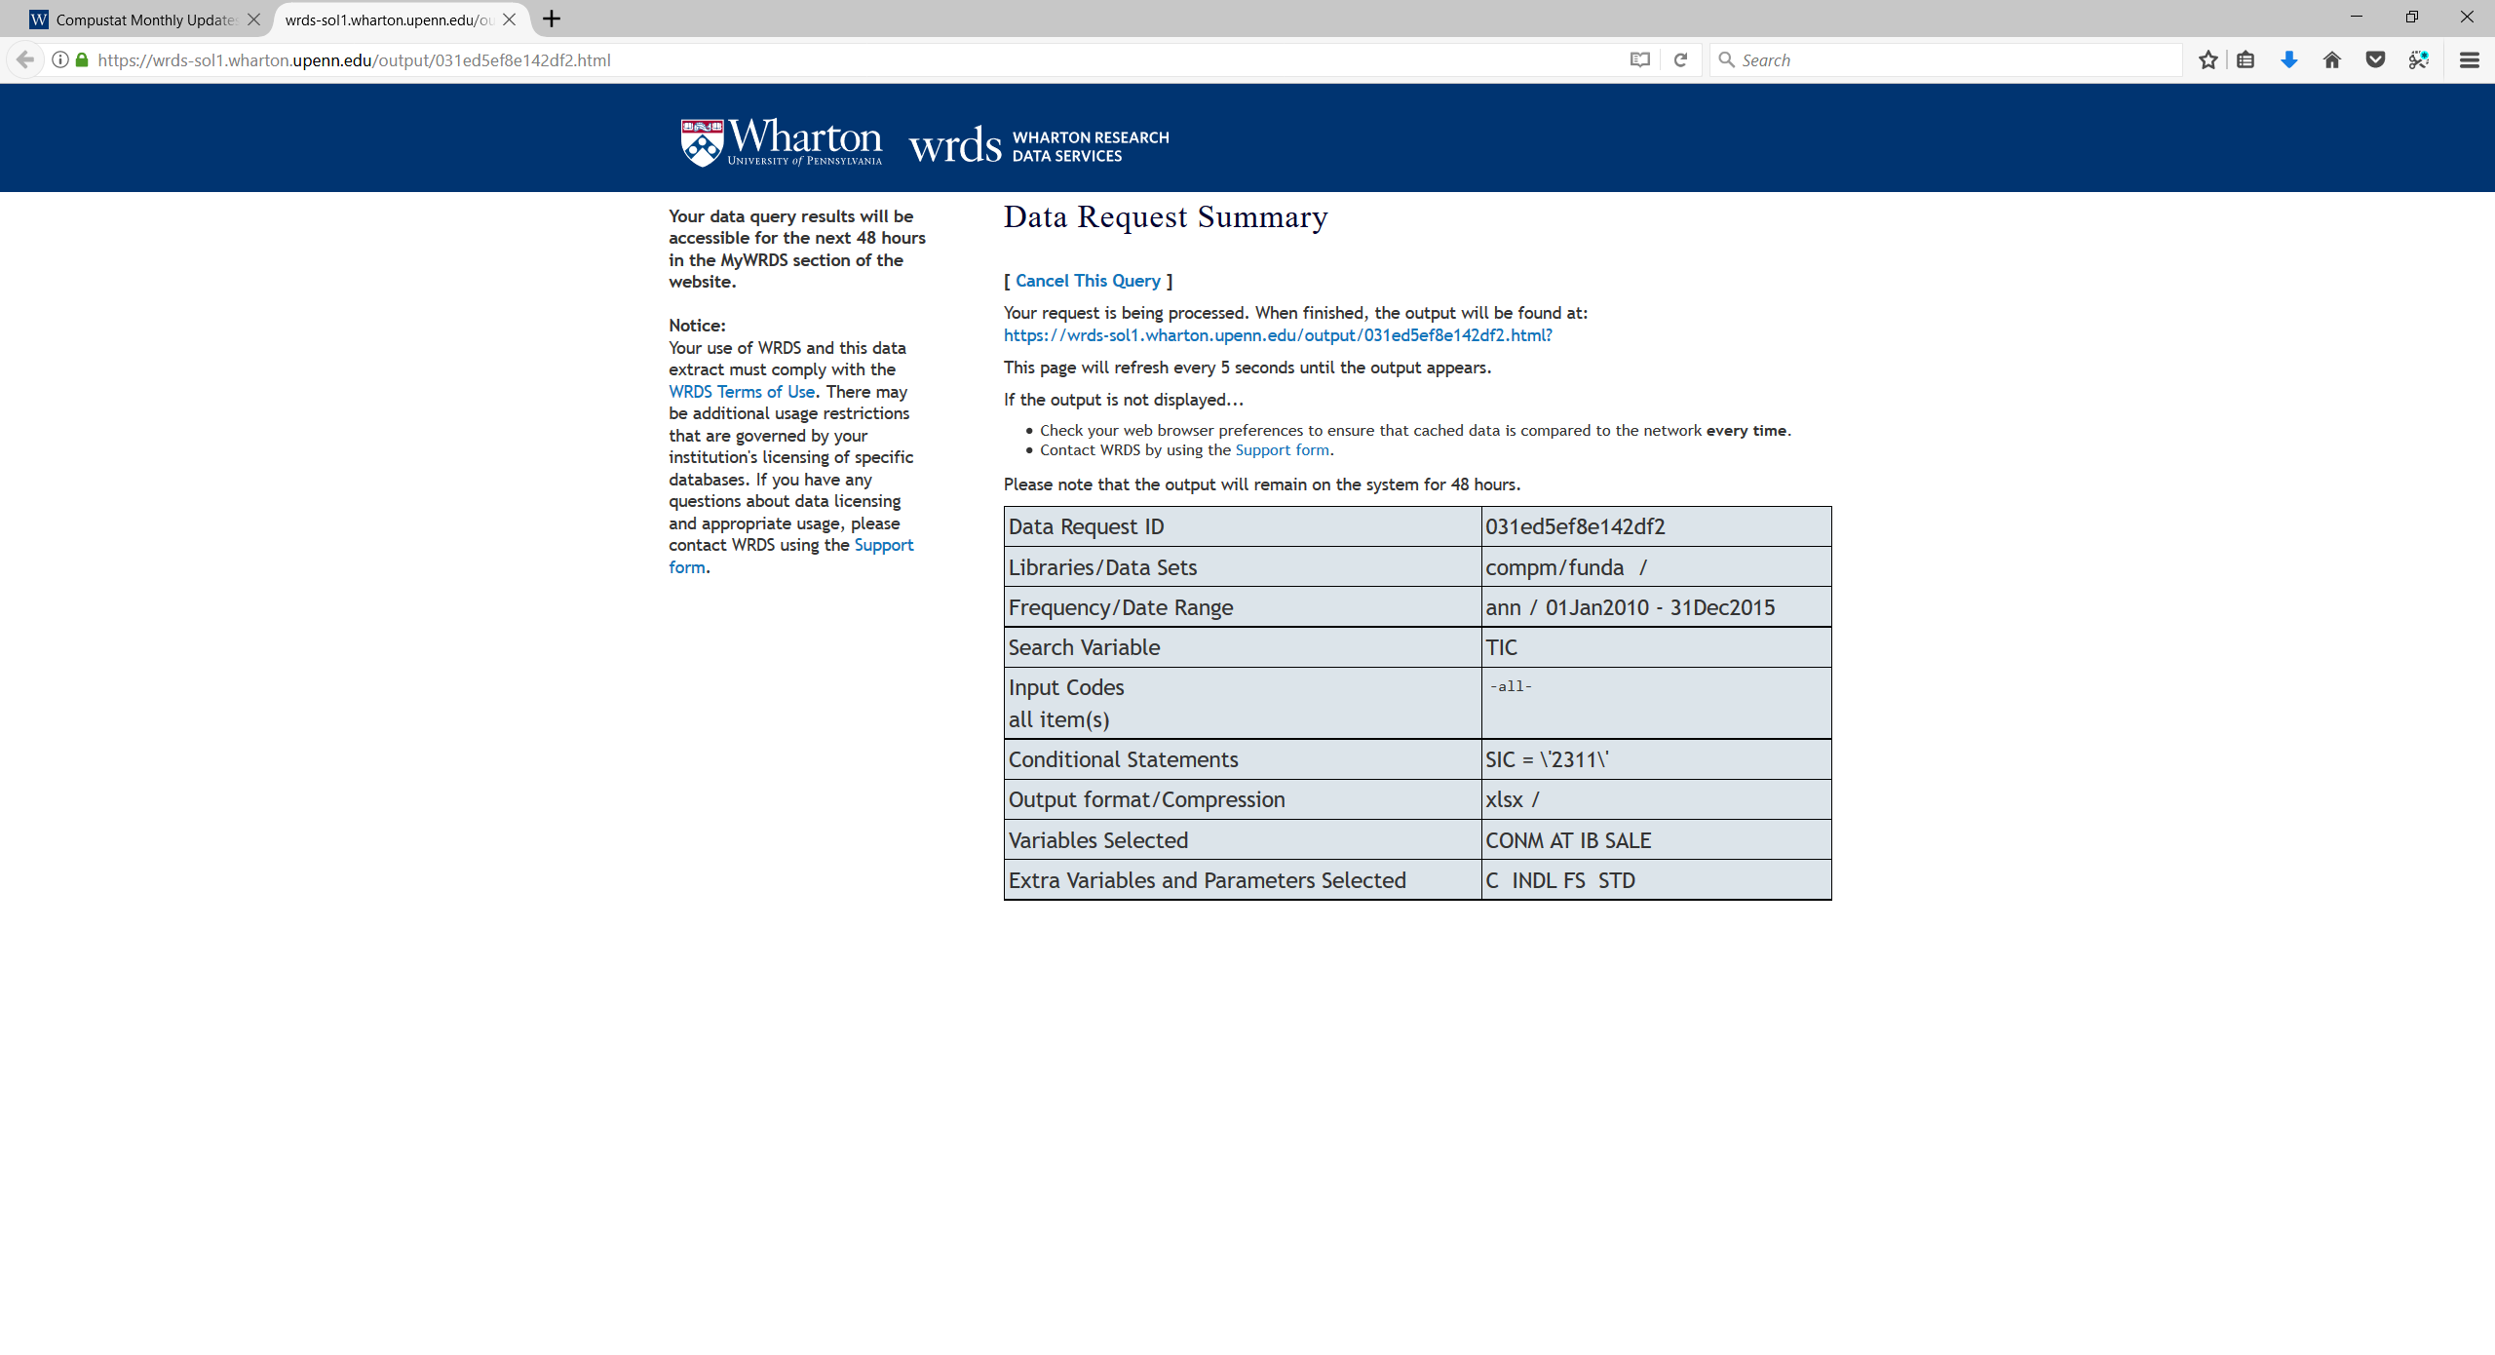

When complete you get this page

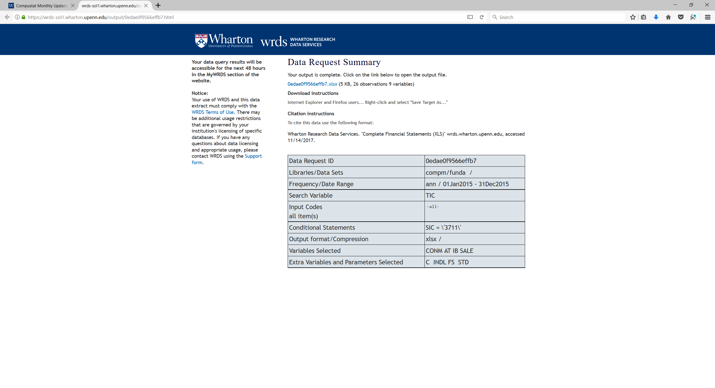

You click on the link to download, I recommend you download and save as something that you can remember and find rather than the default file name, you can open in Excel

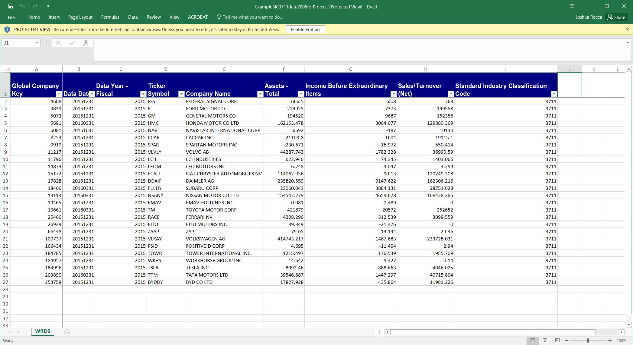

You need to calculate the Margin, Turnover, ROI for EACH company in your sample. Also calculate the average of margin, turnover, and ROI using the individual company values. Use the sort function to determine the company with the highest ROI. Answer the questions, paying careful attention to the instructions on the number of digits, etc. 4.6 and 4.60 are not the same to the system… follow instructions!

NOTE: Average Margin is the sum of the Margin for each company divided by the number of companies, NOT the sum of income divided by the sum of sales…. They are not the same!

For part 2 of the project you will download and analyze the provided data set and create a pivot table.

Once you download the data set, open it in Excel



There are 100 observations in 10 different industries

You need to create a pivot table to compute the sum of income and investment and the average of roi, margin, and turnover for every industry.

Step 1 is to calculate ROI, Margin, and Turnover for each company by adding additional columns to the data. (3 columns)

Step 2 is to create a pivot table, where you calculate the average for roi, margin, and turnover, and the sum for income and investment, separately for each industry (1-10)

After creating your pivot tabe, you will need to answer some questions about your results and upload your excel file (separate file from part 1)

Here is a video on how to create a pivot table

<https://www.youtube.com/watch?v=Ldm3LH4b0z0>

Although the video recommends creating the pivot table in the existing sheet, I recommend placing it in a new sheet.

Your table will need to have 5 summary values for each industry, the average margin, turnover and roi, and the sum for income and investment, you will not need a filter.